Assignment -6

Vishal Subbiah

MM12B035

1a.R

Toshiba

Thu Nov 27 20:04:55 2014

library(itsmr)

## Warning: package 'itsmr' was built under R version 3.1.2

ma_2=arima.sim(1000,model=list(ma=c(1,0.21)))  
arma_12=arima.sim(1000,model=list(ar=-0.4,ma=c(0.7,0.12)))  
  
ma_2_sol=arma(ma_2)  
arma_12_sol=arma(arma_12)  
  
ma_sol1=hannan(ma_2,0,2)  
arma_sol1=hannan(arma_12,1,2)

4a.R

Toshiba

Thu Nov 27 18:51:56 2014

library(sapa)

## Warning: package 'sapa' was built under R version 3.1.2

## Loading required package: ifultools

## Warning: package 'ifultools' was built under R version 3.1.2

## Loading required package: splus2R

## Warning: package 'splus2R' was built under R version 3.1.2

## Loading required package: MASS

xk=arima.sim(2000,model=list(order(0,0,2),ma=c(0.5,0.25)))  
xk=4*xk  
  
xk.psd <- SDF(xk,method='direct')  
  
# Periodogram (could use spec.pgram)  
par(bg='lightyellow',font.axis=2,font.lab=2,cex.axis=1.2,cex.lab=1.2,lwd=2)  
plot(xk.psd,yscale='linear')

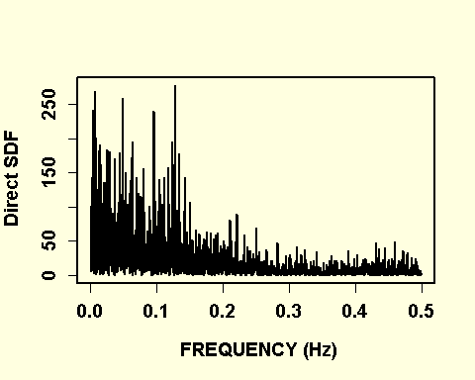

# Welch's overlapping segment averaging method; 128 samples per segment  
xk.psd <- SDF(xk,method='wosa',blocksize=128)  
plot(xk.psd,yscale='linear')

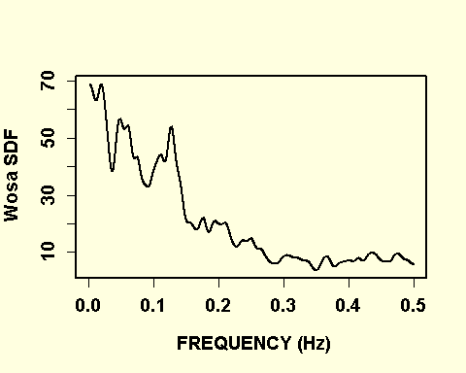

xk.psd <- spec.ar(xk,plot=F)# Parametric method (could give misleading results)  
par(bg='lightyellow',font.axis=2,font.lab=2,cex.axis=1.2,cex.lab=1.2,lwd=2)  
plot(xk.psd$freq,xk.psd$spec)

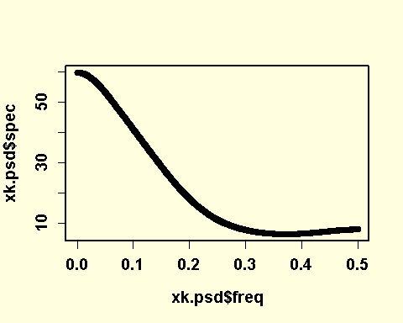

#Daniell Smoother  
xk.psd <- spec.pgram(xk,span=c(7,7),taper=0,log='no')

